Content Management System Installation Manual

Group 3

Members:

Apilada Denmark

Dariano, Michael Jericho

Padilla, Roi Vince

Payaket, Juleus

Bangiacan, Ma. Stephanie Kristina

Dayrit, Aika Vien

Paris, Lovelyn

Sison, Jhen Rose

**Contents**

1. Installing Tasksel and LAMPServer

* Updating your ubuntu server by entering this command “sudo apt-get update”

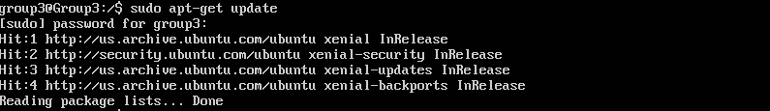

* First, we install tasksel to help us install LAMP server in package rather than one by one installation of LAMP server. Enter command “sudo apt-get install tasksel”

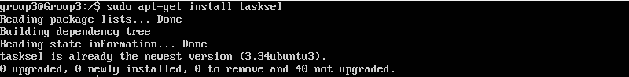

* After installing tasksel, enter the command “sudo tasksel” to select and install the LAMP server.

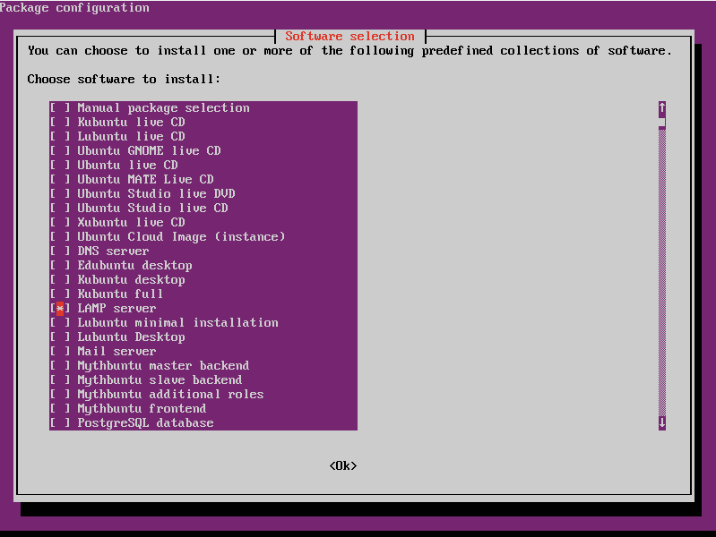

* While the LAMP Server is installing, it will ask for a new password for your MySQL. After that it will continue the installation of the package and DONE.

Note: ”root” is given username for your MySQL.

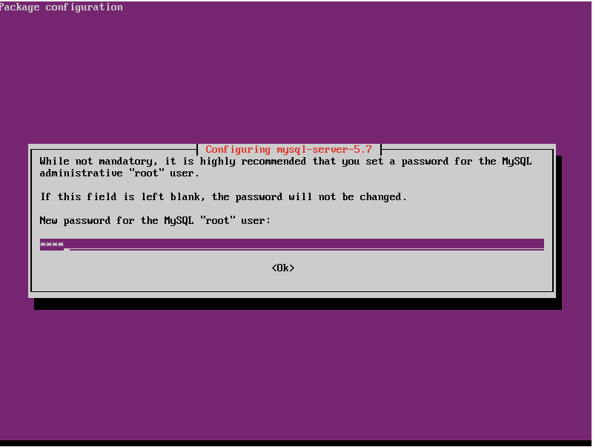

* Ask to Re-enter password

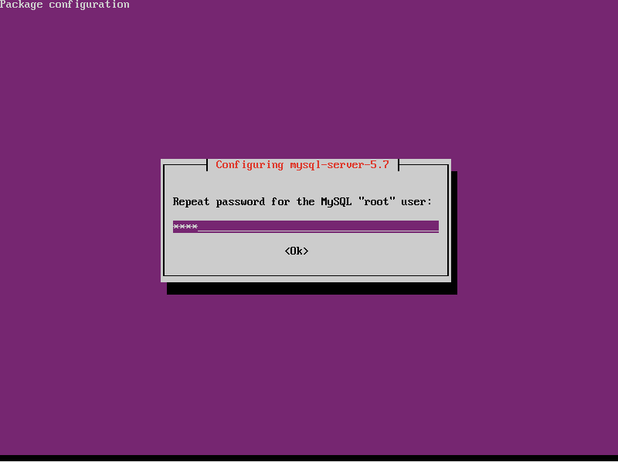

* Access your server using Winscp to transfer the wordpress to the ubuntu server. Transfer and move to directory /var/www/ the wordpress folder.

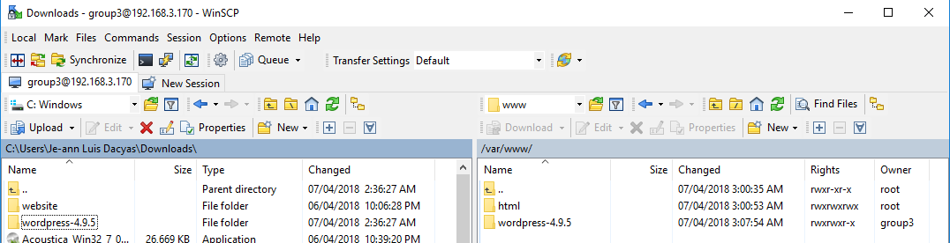

1. sudo chown www-data:www-data -R /var/www/html/wordpress. The web server ownership of the “wordpress” folder. This allows the web server to access the files



1. Log in to MySQL and create a Database.

* Type and enter mysql -u root -p

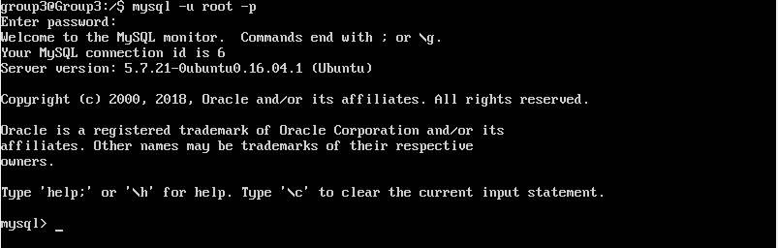

* Type and enter create database wordpress;. It will just create a database name wordpress for the server. And type exit and enter after database is been created.

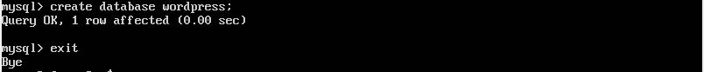

1. Hosting the wordpress.

* Go back ubuntu server. Go to etc/apache2/sites-available/ and type and enter sudo cp 000-default.conf wordpress.conf. It will copy the file 000-default.conf and it name as wordpress.conf.

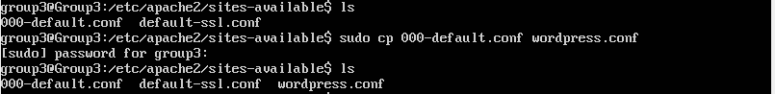

* After you copy edit the wordpress.conf file by the command of “sudo vi wordpress.conf”. In the DocumentRoot change the directory /var/www/html to var/www/wordpress and save it.

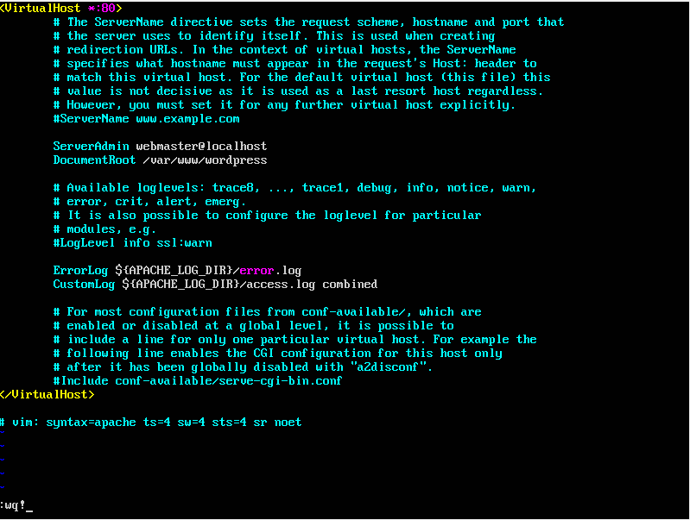

* After wordpress.conf is edited. Disable the 000-default.conf and enable the wordpress.conf by using this command “ sudo a2dissite 000-default.conf ” to disable and “ sudo a2ensite wordpress.conf ” to enable it. And also type and enter “sudo service apache2 reload” after it.

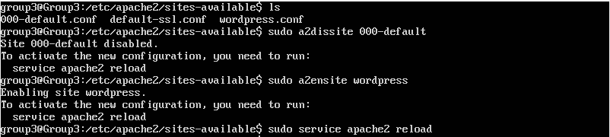

1. To check if the wordpress is working. Open a browser and enter the IP address of your ubuntu server.

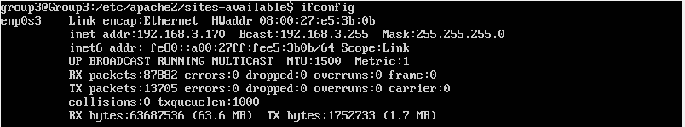

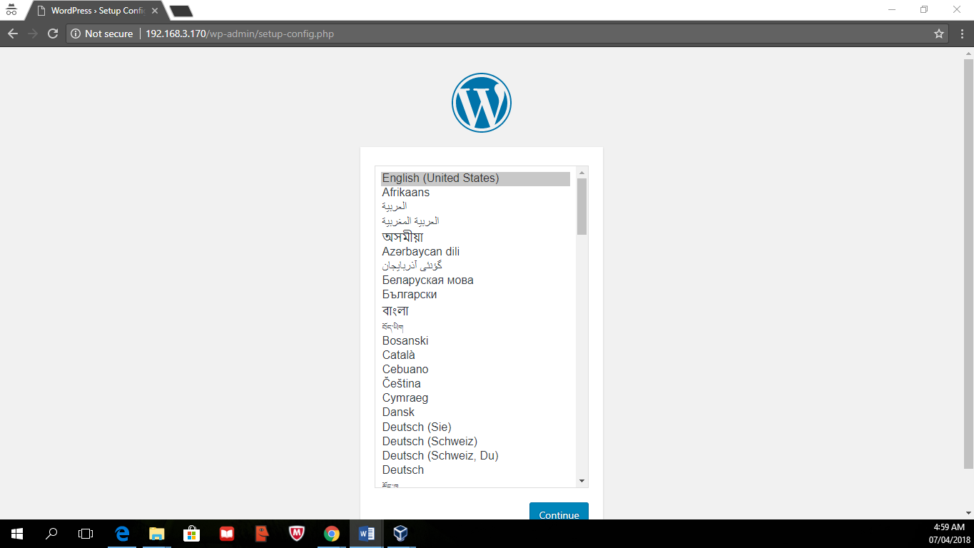

1. Final installation of wordpress.

* Select a language and click continue.



* After the wordpress will ask to do the following items before proceeding.

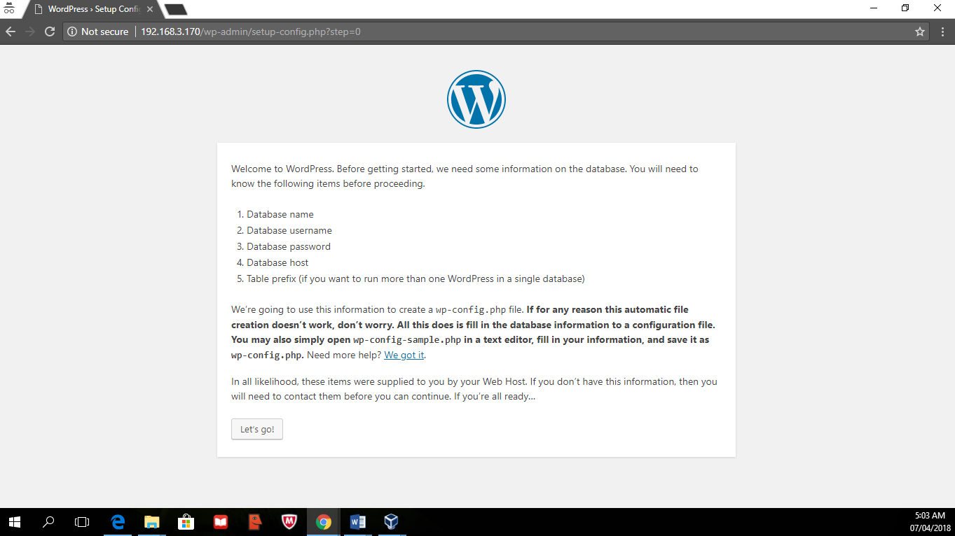

* Fill in Database Name(name of the database created earlier[Item #:7]), Username(Given username “root”), and lastly the password of your MySQL(Item #: 4). This will connect your wordpress to the database that you`ve created.

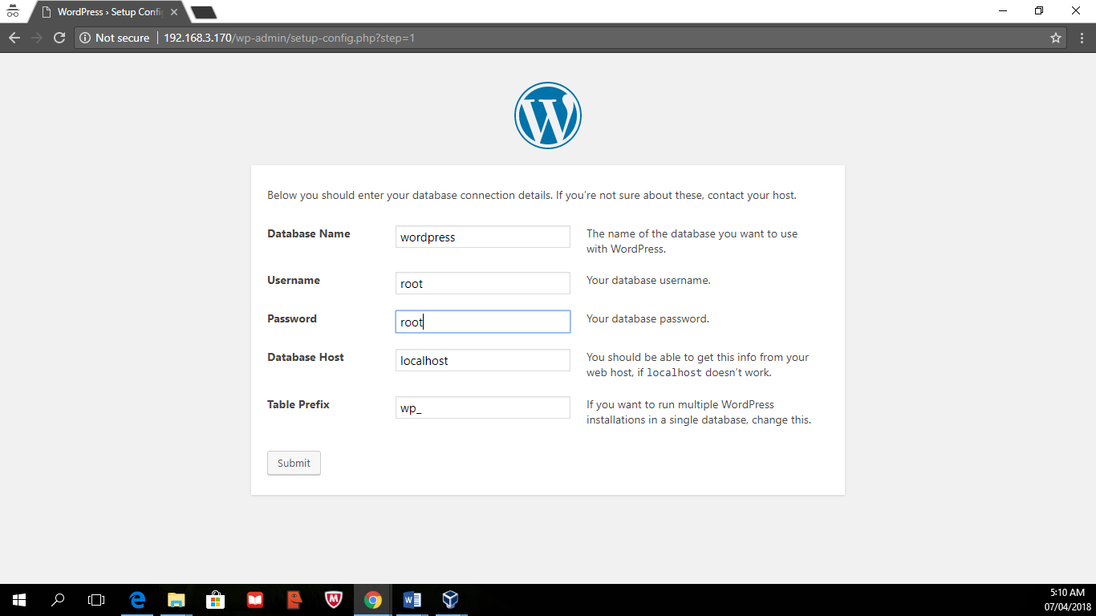

* After you do the following items click “Run the Installation ” to install the final part of the wordpress.

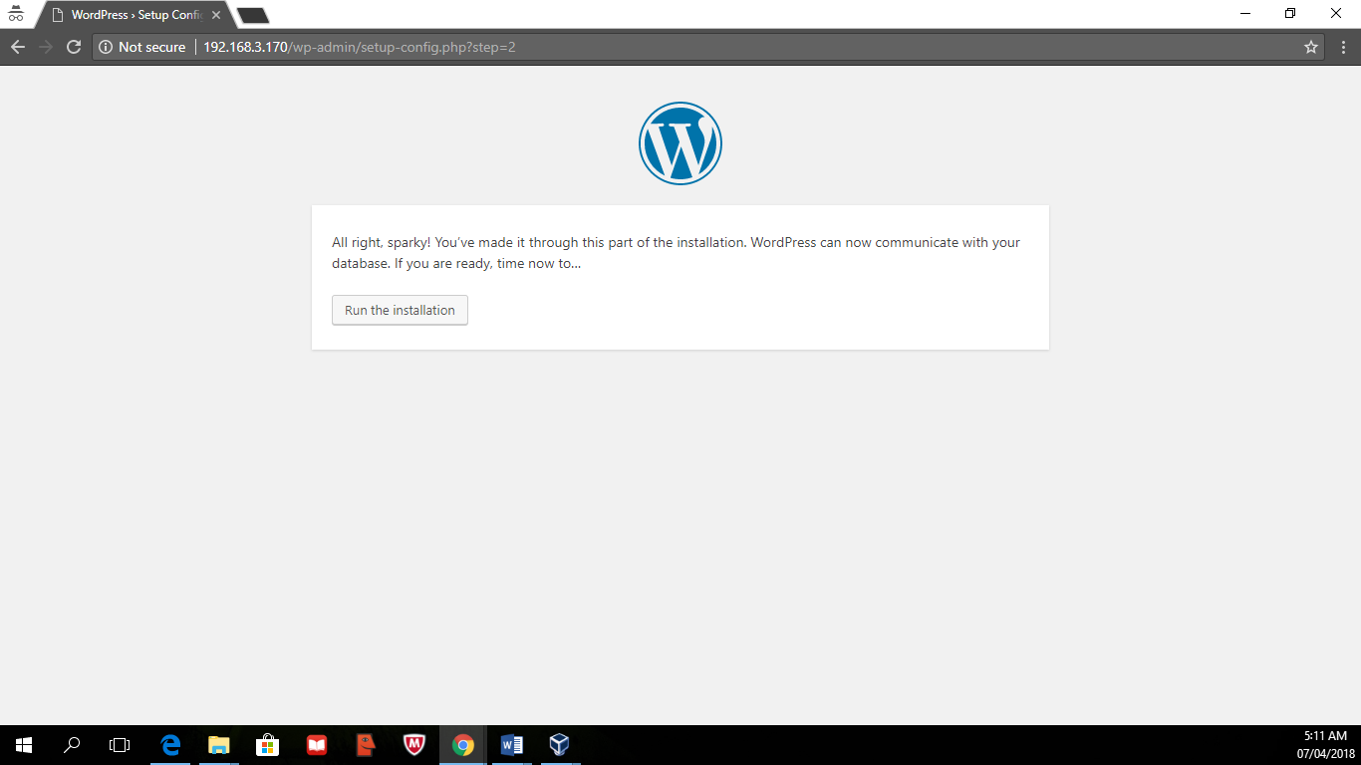

* It will ask to input the following information needed before clicking the “Install Wordpress”.

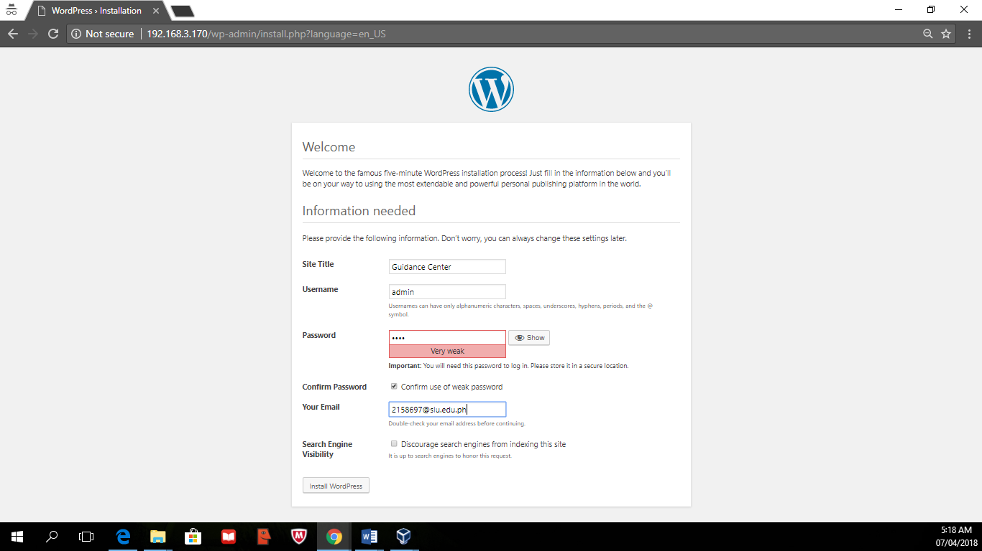

* Now that it is success you may now proceed to the login page.

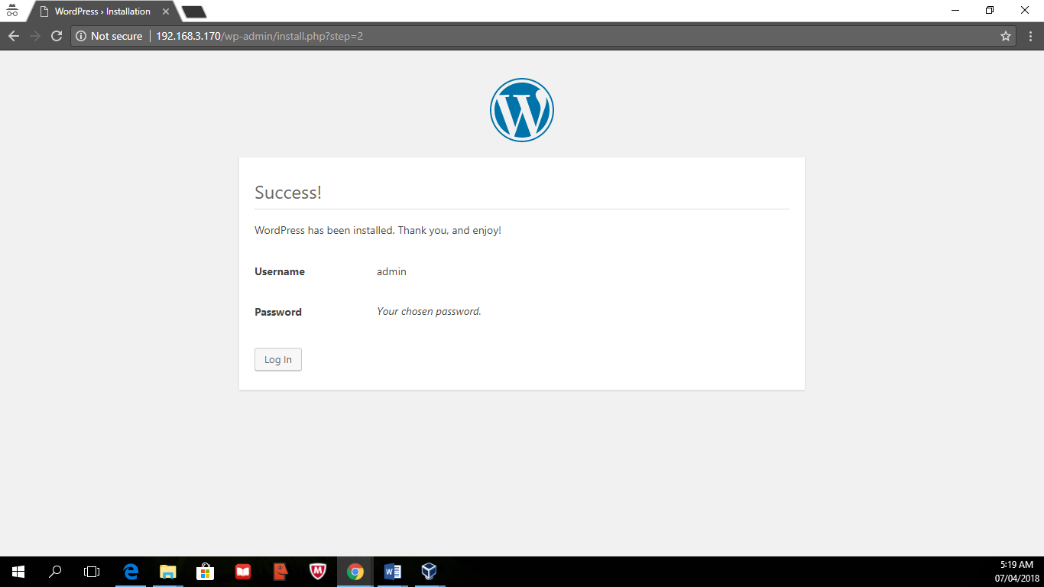

* Enter your wordpress account so that you can now create or customize your website.

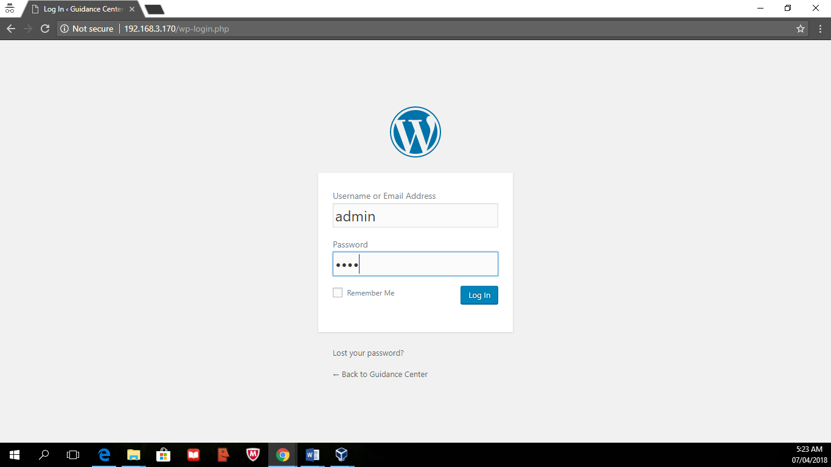

* Note: when you going to access your website to edit again, enter IP address/wp-admin. E.g. 192.168.0.124/wp-admin

